

**TSDS Manage Claim Sets**

A Claim Set defines the access to which a source system has to the data in an LEA’s Individual Operational Data Store (IODS). Access may include any or all the following: Create, Read, Update, and/or Delete (CRUD).

TEA has established some predefined claim sets for LEAs to utilize or depending on the data required, districts can create a specific claim set. The predefined claim sets currently available are **Assessment Vendor (ECDS), Ed-Fi Sandbox, Finance Vendor, HR Vendor, HR/Finance Vendor, Read-Only All Resources (Third Party Vendors), SIS Vendor, SIS Vendor with Staff Profiles, and SIS/HR/Finance Vendor.**

1. Log into **TEAL**.
2. Click on **Texas Student Data System Portal** link.

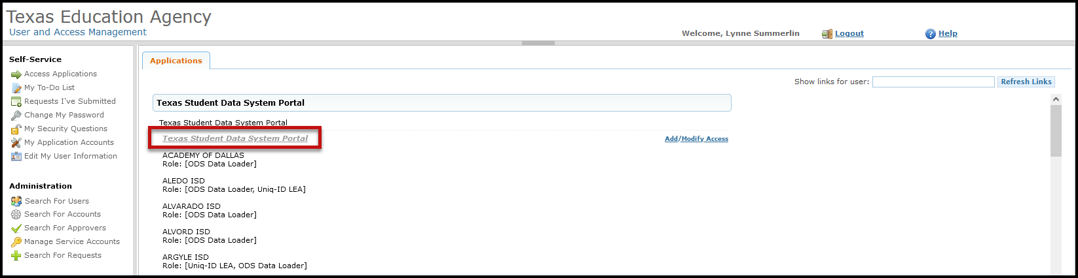

1. Click on **DMC** or the **Manage IODS** button.

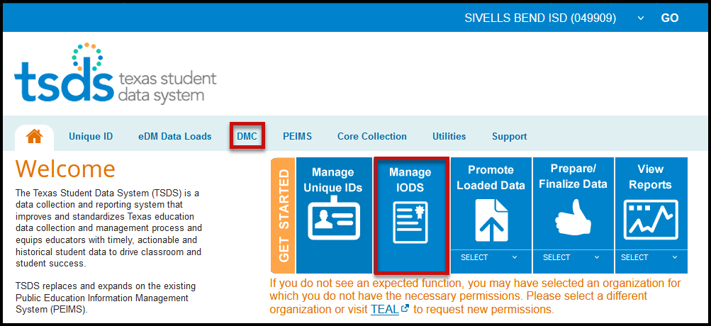

1. On the **Data Management Center (DMC)** screen select **Admin > Manage Claim Sets.**

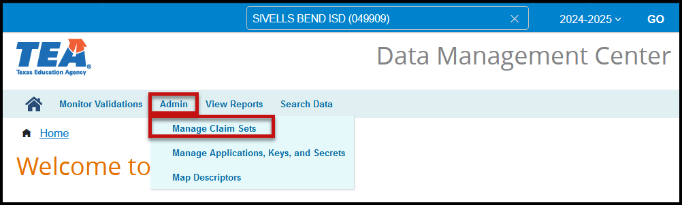

1. The Manage Claim Sets screen appears.

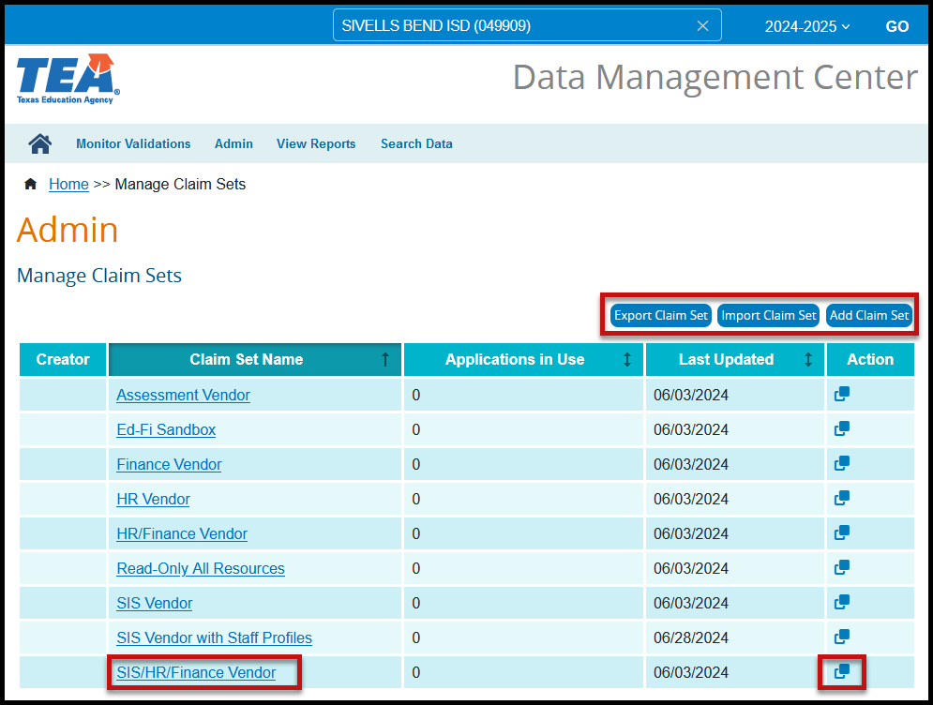

1. From this screen the user can select to Export a Claim Set (json format), Import a Claim Set, or Add a Claim Set. These options are rarely used by the district.
2. LEAs may also view the CRUD values for a claim set by clicking on the hyperlink for that claim set.

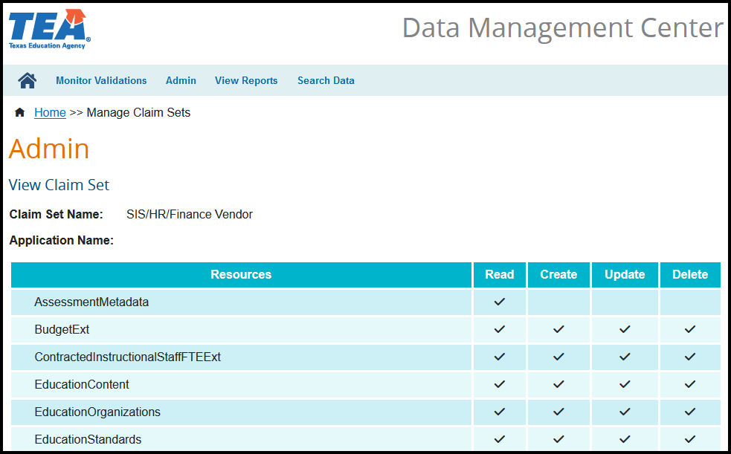

1. By clicking on the copy icon LEAs can copy an existing claim set to create a new claim set for their district.

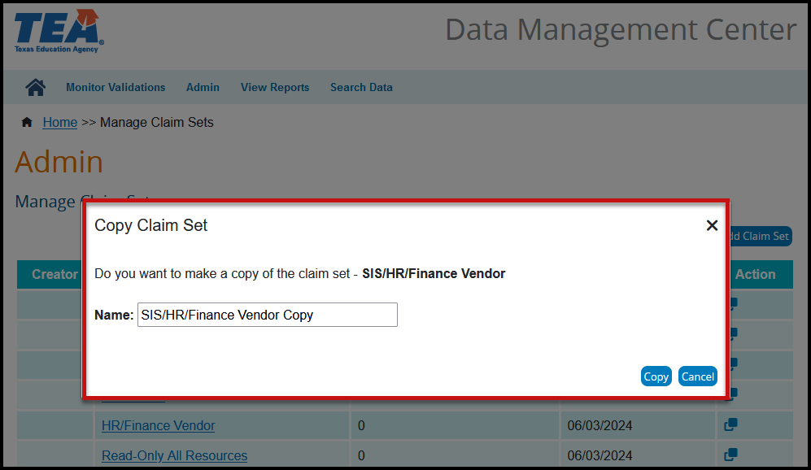

Limited Consent: ESC Region 11 grants permission to attendees of this session to reproduce and distribute designated resources and materials provided during the presentation.